**SMB & SSH Brute force:**

**192.168.100.50**

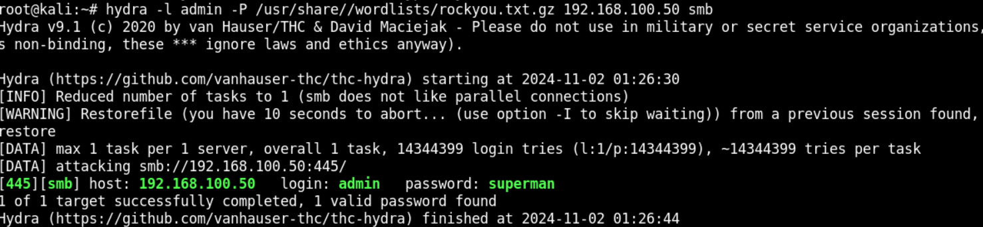

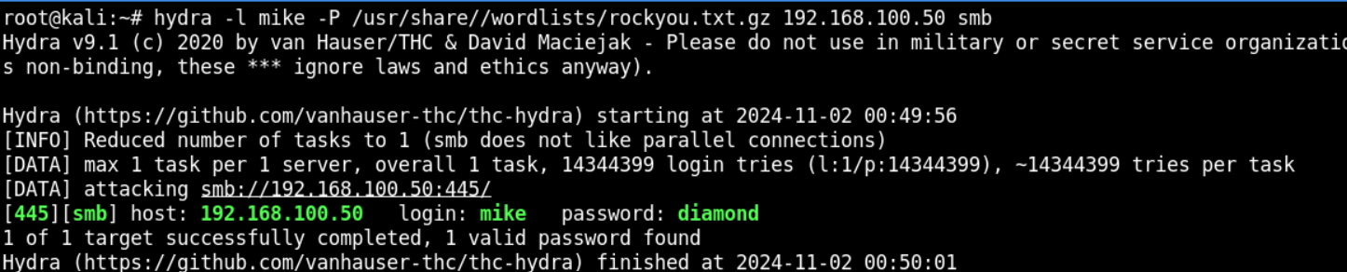

**192.168.100.51**

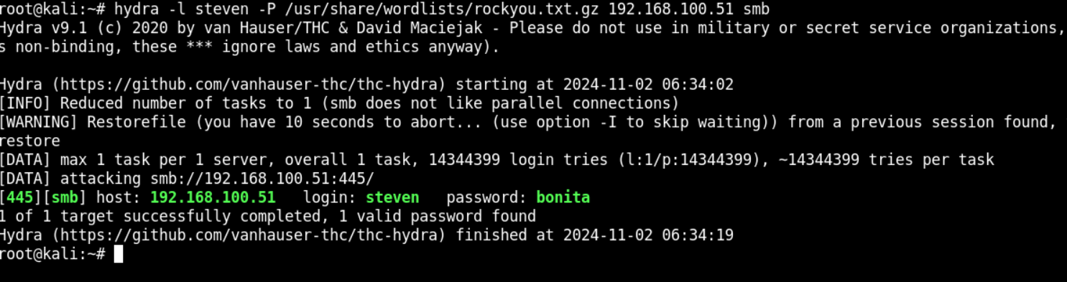

**192.168.100.52**

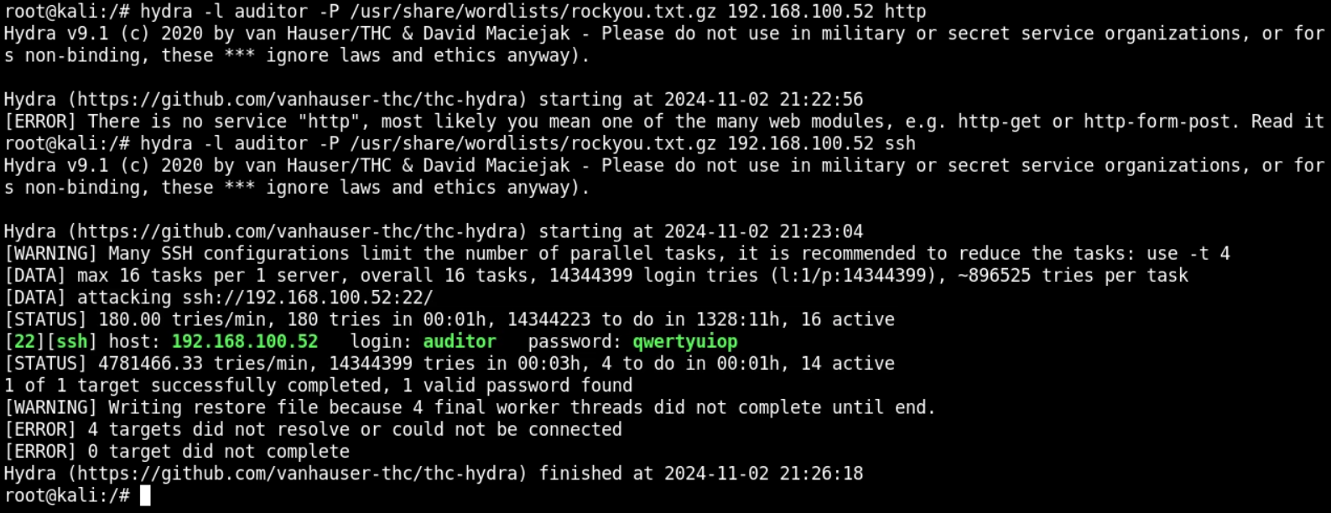

**192.168.100.55**

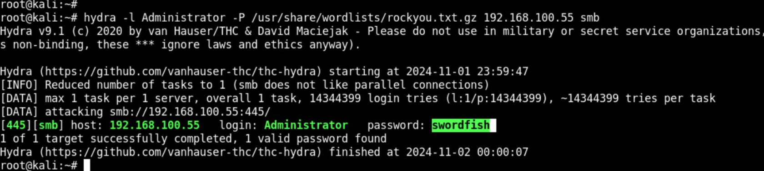

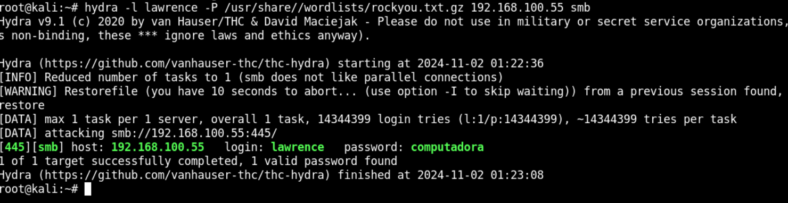

**Answer Techniques:**

**WordPress – 192.168.100.50 :**

Plugins installed on WordPress site (3)

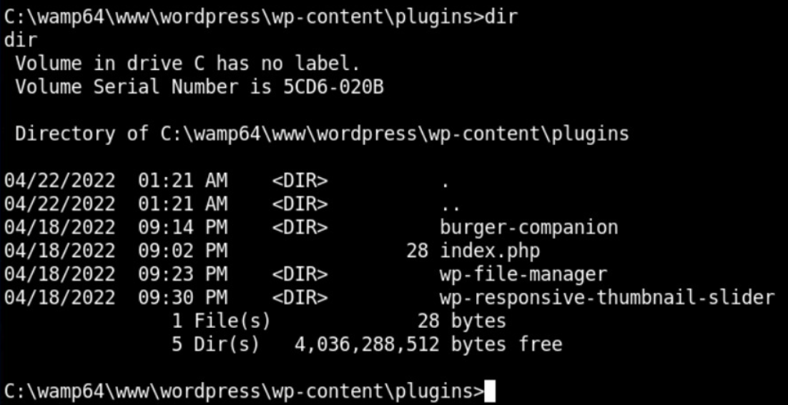

User accounts on system (4)

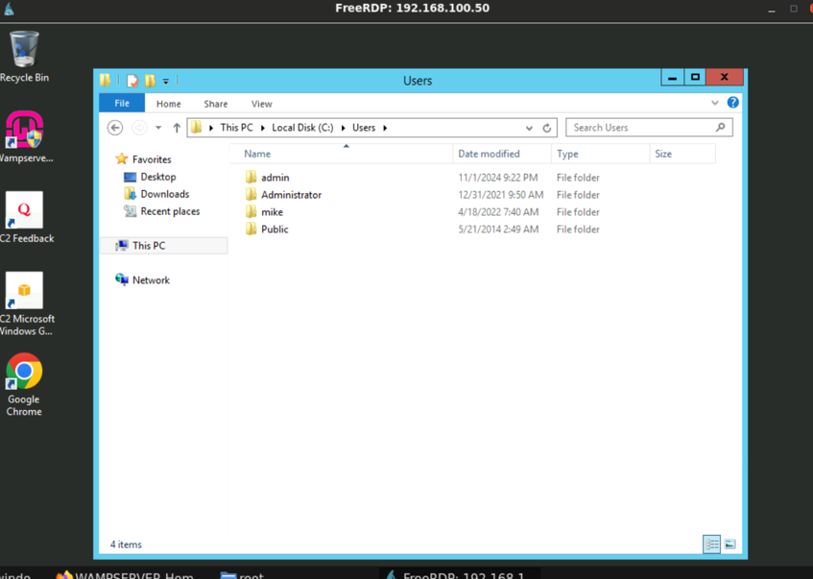

**Drupal – 192.168.100.52 :**

**http://192.168.100.52/drupal/profiles/minimal/**

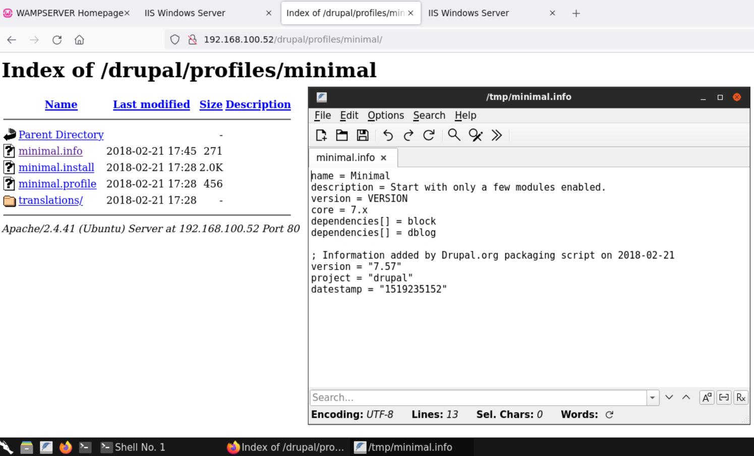

**http://192.168.100.52/drupal/CHANGELOG.txt**

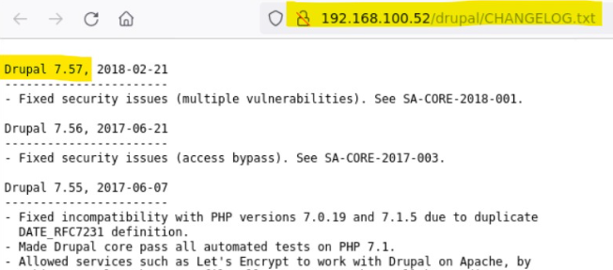

**Command:** ssh [auditor@192.168.100.52](mailto:auditor@192.168.100.52)

**Password:** qwertyuiop

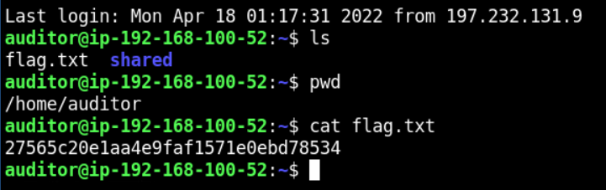

uname -r to check linux version

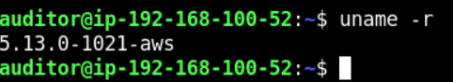

**xfreerdp /u:root /p:hacker123 /v:192.168.100.52 ---- (Misconfiguration, any password will work)**

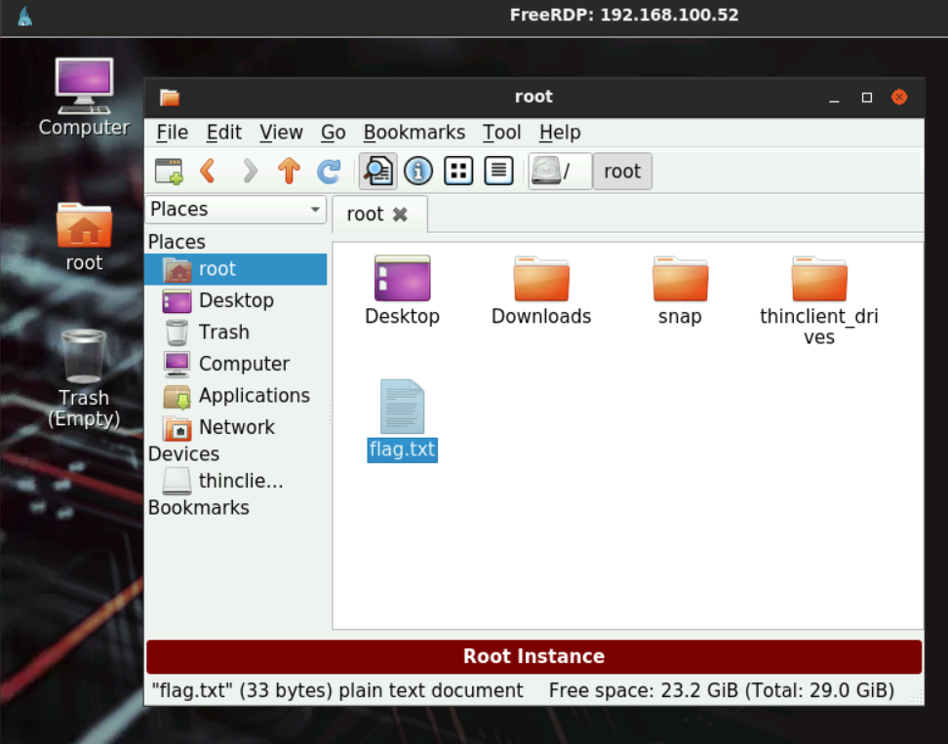

**WINSERVER-03 – 192.168.100.55 :**

